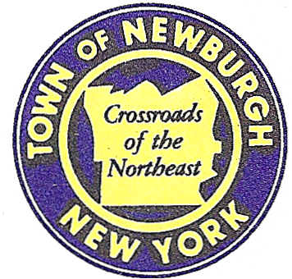

TOWN OF NEWBURGH
_______Crossroads of the Northeast __________________________
OLD TOWN HALL
308 GARDNERTOWN ROAD NEWBURGH, NEW YORK 12550

PLANNING BOARD
JOHN P. EWASUTYN, CHAIRMAN
TELEPHONE 845-564-7804
FAX 845-564-7802
E-MAIL: planningboard@townofnewburgh.org

PLANNING BOARD AGENDA

DECEMBER 17th, 2015

*PLEASE NOTE: The Planning Board Meeting will start at 7:00 P.M. and all Applicants/Representatives
are to be present at that time. The Meeting will be held in the Meeting Room of Town Hall,
located at 1496 Route 300, Newburgh NY.*

- Matrix Business Park at Newburgh (2015-26) PUBLIC HEARING
Route 17K
Section 95, Block 1, Lot TBD
(portion of prior lots 4.12,54.1,69.25 &49.12)
Zone: IB
Rep: Langan Engineering, Environmental,
Surveying & Landscape Architecture
707 Westchester Ave, Suite 304
White Plains, NY 10604

2. Restaurant Depot (2015-33) SITE PLAN /INITIAL APPEARANCE
NYS Route 300
Section 95, Block. 1, Lot 8
Zone: IB
Rep: Larry Marshall, P.E.
Mercurio Norton Tarolli & Marshall
45 Main Street
Pine Bush, NY 12566

3. Seriota Site Plan (2015-28) AMMENDED SITE PLAN
NYS Route 17K
Section 94, Block 1, Lot 61
Zone: IB
Rep: Engineering & Surveying Properties
71 Clinton Street
Montgomery, NY 12549

